

What is the Coronavirus?

You will be spending a lot of time at home. 



You can play a game with your family.

You can help your mom and dad clean up around the house.

You can draw a picture.

You can play outside.

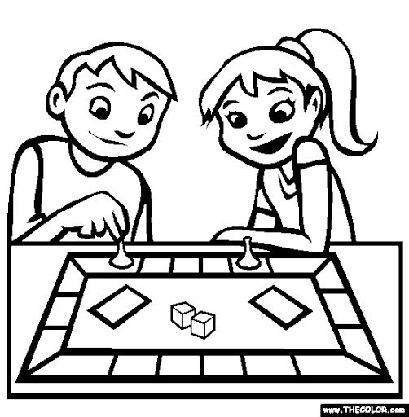

The Coronavirus makes people feel sick.







How can you keep everyone safe

Some people who have the Coronavirus have:

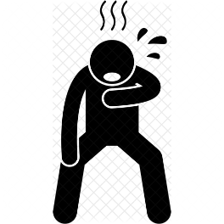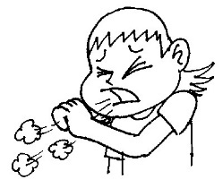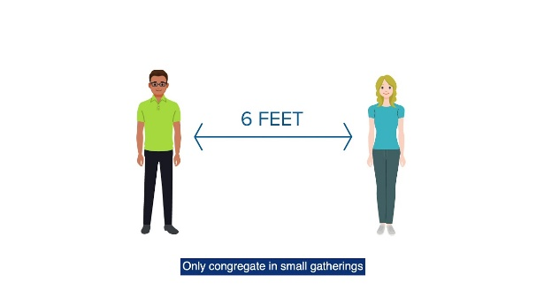

We can cough into your elbow.

You can practice social distancing by Staying 6 feet apart from your friends.

You can wash your hands.

High fever

Dry cough

Hard time breathing

They are also very tired

You might be feeling:

Scared

Frustrated

Sad

Confused

Bored

And that’s okay!

We are all going through these emotions right now.

Some people are very sick and must stay in the hospital.

Most people stay home to get better.

Stay happy and healthy at home my friends!

It might be confusing and hard to understand what’s going on. Just know you are not alone, and everyone is working together to keep each other safe!