**Who, What, Where, When, How?**

**The Story of Covid-19**

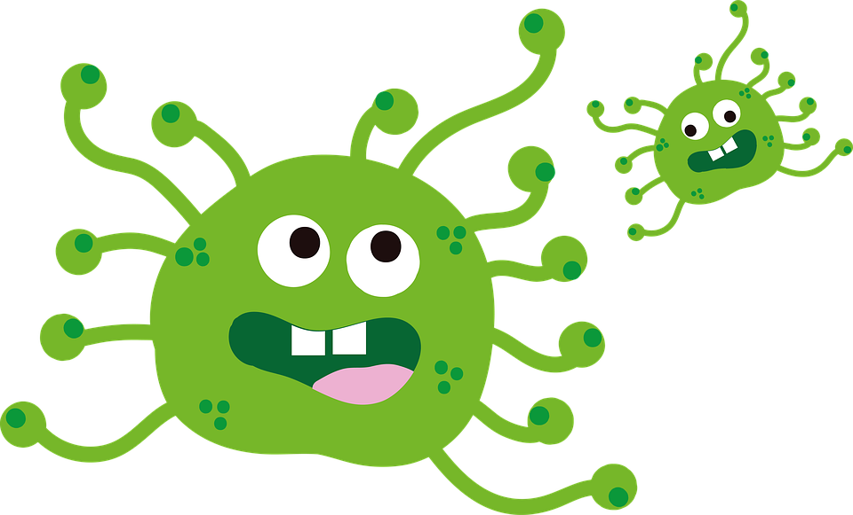

By Ashley Lange

**What?**

**The corona virus is like the mom or dad of the cold or flu. It is stronger and more powerful.**

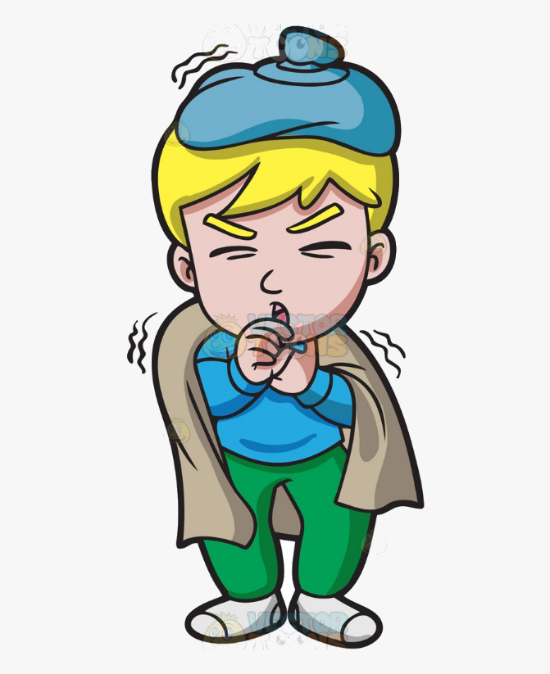

**Covid-19 also known as the Coronavirus makes you feel sick.**

**Where?**

**The virus has made its way all the way around the world.**

**Who?**

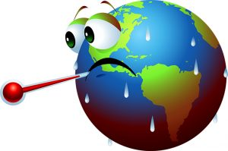

**The virus has impacted people of all ages, shapes, sizes, and color.**

**When?**

**It is more dangerous for older people like grandparents and people who are sick.**

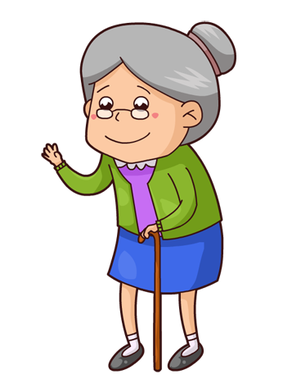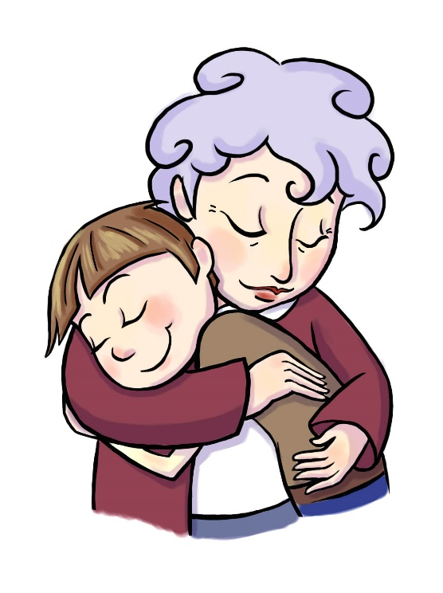

**Covid-19 began during December 2019 and has continued months into 2020.**

**How?**

**It may be scary, and it may seem big, but there is something you can do to help.**

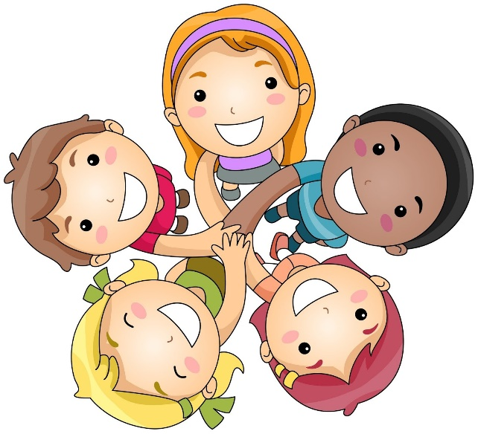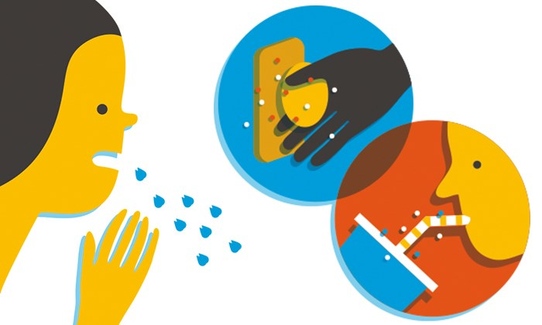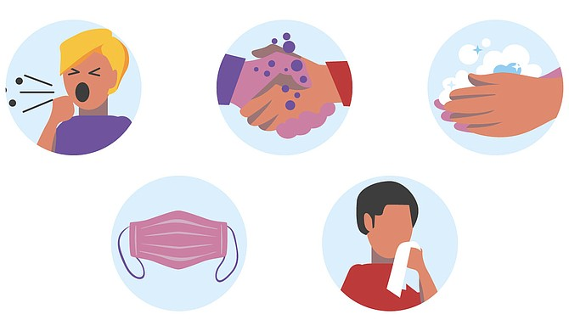

**Covid-19 can spread easily, and scientists are unsure of the way it spreads so we must be careful**

**Cover your mouth, avoid touching others, and wash your hands often.**

**Something called social distancing can also help to stop the spread.**

**Protect yourself and others by staying home.**

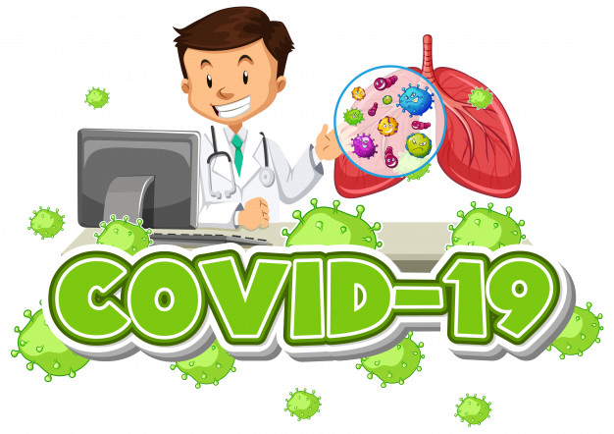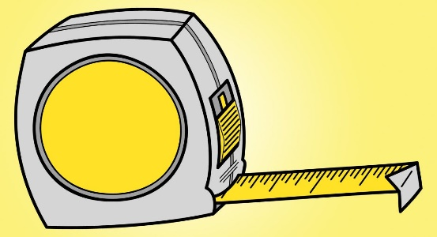

**6 feet!**

**Social distancing means staying away from people you don’t live with. Scientists suggest 6 feet.**

**But that can be boring, so let’s get creative!**

**Being stuck at home can cause different feelings.**

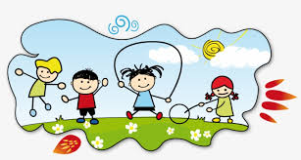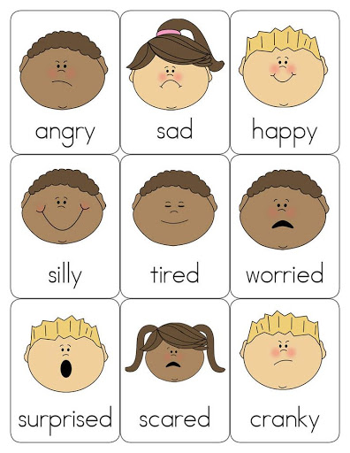

**What are some fun things you can do in your house or in your back yard?**

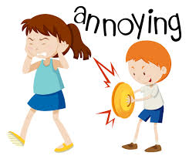

**Although it is may be a stressful or confusing time, we can take this time to learn about ourselves and work on becoming the person we want to be.**

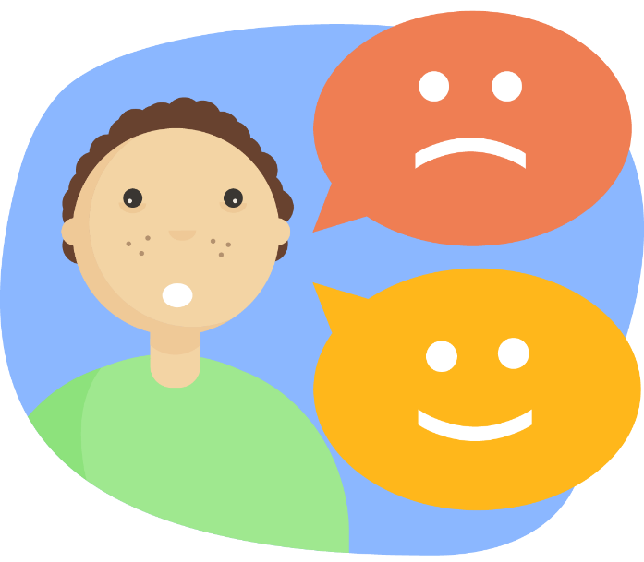

**We can use this time to learn our feelings and to find ways to show them.**

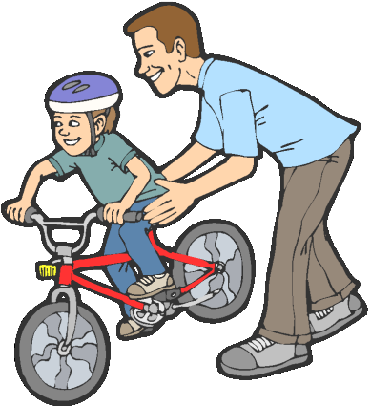

**Empathy**

**Some people might be feeling sad or scared. We can try to understand and find ways to make them feel better.**

**Set some goals!**



**Use problem solving skills to think about more than one way to reach your goal.**

**Write letter to family friends or neighbors.**



**Stay positive and focus on what’s ahead and become the best person you can be.**

**We can all get through this together, you are not alone.**