CORONAVIRUS
What Is It And How Can I Help?
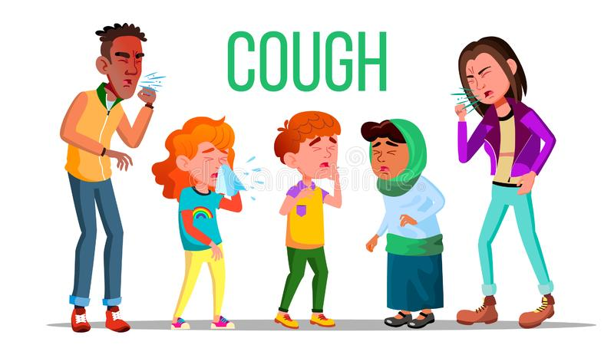

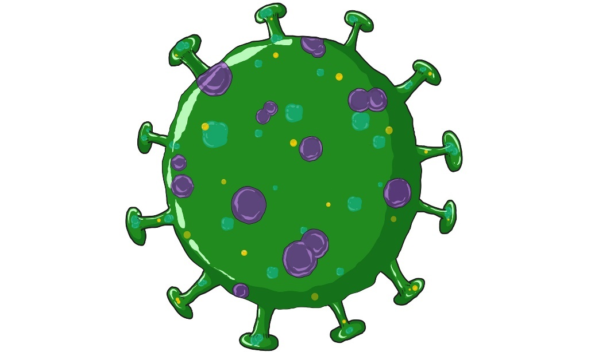

The Coronavirus is a sickness that can give you a fever, cough, or make breathing very hard.
A Narrative for Children

The goal is to reduce the spread of the virus. You can help by staying home.

Many hospital workers are working hard to keep people safe. But they need your help!
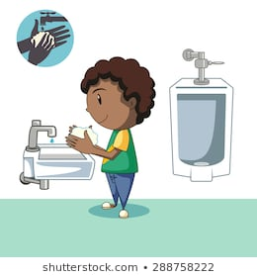
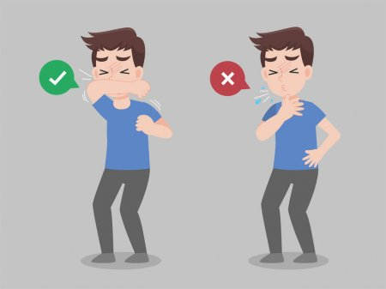

You can also help by covering a cough or sneeze with your elbow and never touching your face.
And by washing your hands often, for at least one minute (sing the ABCs)!

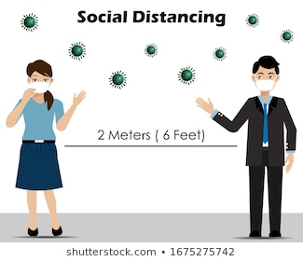

Remember to stay 6-feet apart from other people – this is called social distancing.

Most schools and stores are closed so they can help stop the spread of the virus.

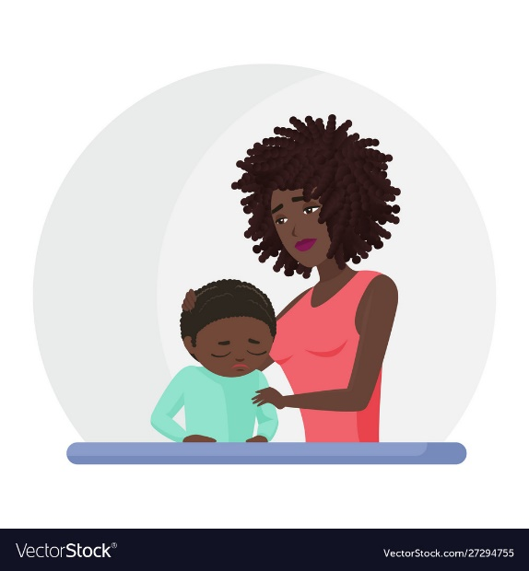

Not being able to go places may make you feel bored. But there are many activities you can do at home.

You may be feeling worried but, with the help of healthcare workers and you, this sickness will go away.

Some things you can do are color, play games, and go outside (remember to wash your hands after every activity)!

If you have any questions or worries don’t be afraid to ask someone you trust for help.

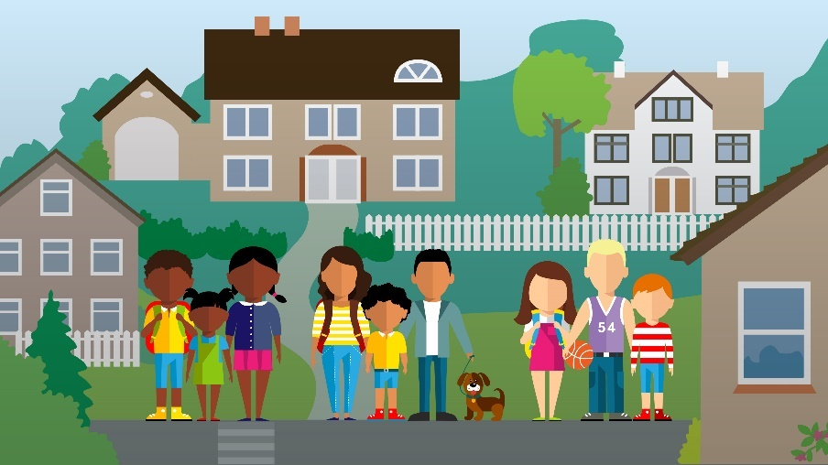

The
End!

Someday soon, the germs from Coronavirus will move away from us and everything will be back to normal!

Sources for Pictures
https://cdn.mos.cms.futurecdn.net/byP6wEtR9xbRBXqronPfiK.jpg
https://thumbs.dreamstime.com/b/cough-people-vector-coughing-concept-sick-child-teen-sneeze-person-virus-illness-illustration-143830877.jpg
https://cdn1.vectorstock.com/i/1000x1000/54/65/sick-boy-lying-in-bed-ill-cold-flu-disease-illness-vector-27285465.jpg
https://image.shutterstock.com/image-vector/kid-washing-hands-after-bathroom-260nw-288758222.jpg
https://cdn1.vectorstock.com/i/1000x1000/47/55/african-american-black-mother-supporting-crying-vector-27294755.jpg

