Coronavirus  What is happening around us right now?  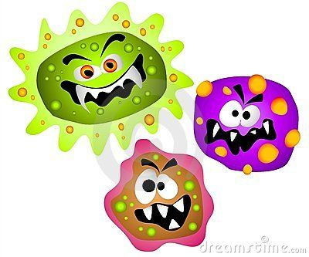 | 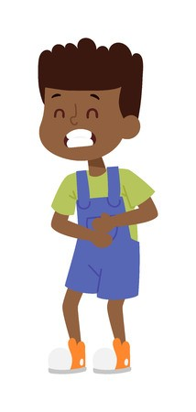  There are little germs going around in the world right now that are making people sick. These germs are called Coronavirus.
These germs cause people to cough, sneeze, have a fever, and have trouble breathing. This sickness is becoming a problem, and we need to figure out how to solve it! | One way to solve the problem would be to stay home. When people feel sick, they have to stay home so that no one else gets sick.
Even if you are not feeling sick, it is best for you to stay home in order to stay safe. | 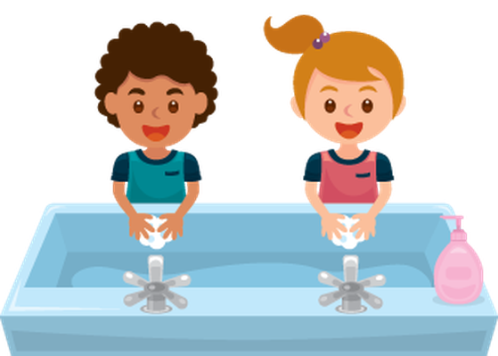  Another way to solve the problem is to make sure to cover your cough with your elbow and to wash your hands regularly, for 20 seconds so you don’t get sick.
Spend this time at home with your family so that you can play with your friends when everyone is feeling better! | It is important to do some schoolwork while you are staying at home, so you don’t fall behind.

Once everyone feels better, the problem will be solved! Everyone can go back to school and play with their friends!  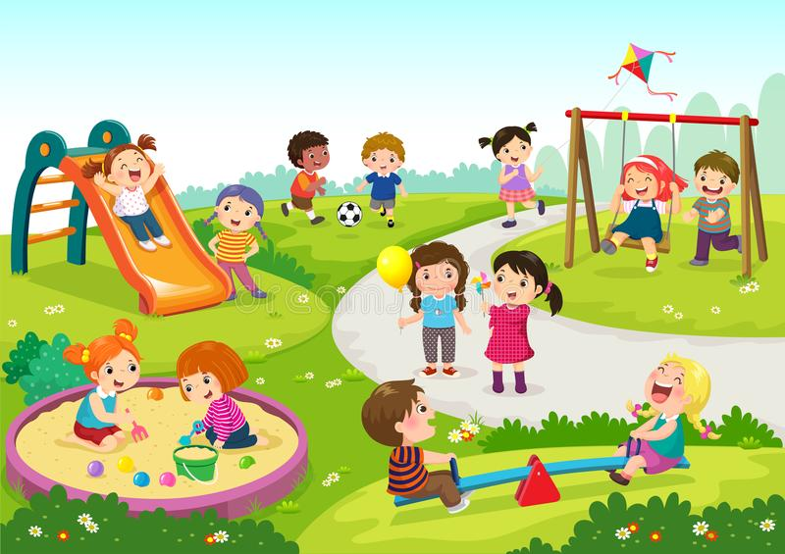 | 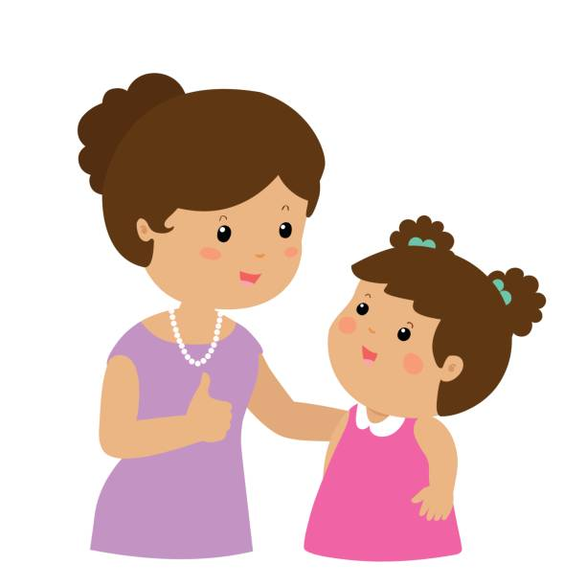  Sometimes it is hard to solve big problems like this one. Do not be afraid to ask a grown up if you have any questions about Coronavirus.

