LESSON #1: SOLVING PROBLEMS

Book Option #1: “Rose Revere, Engineer” by Andrea Beaty

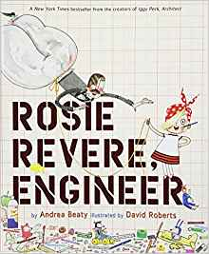
Rosie Revere dreams of becoming a great engineer. Afraid of failure, and what other people think, Rosie hides her inventions. It is not until Great-Great-Aunt Rose visits that she realizes that failure can lead to the best problem-solving.

Prompts for Writing and Reflection:
- What happened in this story? Who are the characters?
- In the beginning, why did Rosie hide her inventions?
- Have you ever felt like hiding something about you? Who supports you to be yourself?

Application Activity #1: Ping Pong Scoot

Directions:
The objective of this game is to give players a spoon with a ping pong ball on it and have them race through their lanes until reaching the end without dropping the ping pong ball. The game will begin with one team member at a time. The next player can start only after their previous team member has reached the end.
- Split the class into three teams.
- Take the kids outside where they can spread out. There should be three separate lanes for each group
- Use cones to create the different lanes for each team (make it challenging and fun with twists and turns!)
- The first team to have all the members reach the end of their lane without dropping the ping pong ball wins.
- New rules can be incorporated within different rounds in order to increase difficulty and cause them to put their problem-solving thinking caps on!

Rules for different rounds:

Round 1: The kids can carry the spoon in any way they want and walk at any pace they want.

Round 2: The kids can carry the spoon any way they want, but they must have a fast-walking pace.

Round 3: The kids can go at any pace they want, but they can only carry the spoons by putting the ends in their mouths.

Materials Needed: plastic spoons, ping pong balls, cones (or something equivalent)
LESSON #2: SETTING GOALS

Book Option #1: “YOU” by Sandra Magsamen

This book reveals the importance of questioning, considering different points of view, making mistakes, and positive thinking when reaching for your goals

Prompts for Writing and Reflection:
- What happened in this story? Who are the characters?
- What are your dreams? What do you want to accomplish in your life?
- What are you curious about? Who encourages you in your life?

Application Activity #1: Goal Setting Like a Superhero

Directions:
- Have a group discussion about what goals are and why they are important. Relay to the students that they are all superheroes and can reach any goal they set their minds to.
- Allow the students to pick out their own superhero names and complete the goal worksheets shown below.
- The students can color and decorate their goal worksheets any way they like. Once they are finished, have the students to go around the room and display their work—explaining their goal and how they can reach it
- After sharing, ask some volunteers for other ideas on how their classmate can reach their goal.

Materials Needed: Goal Setting Like a Superhero Worksheets

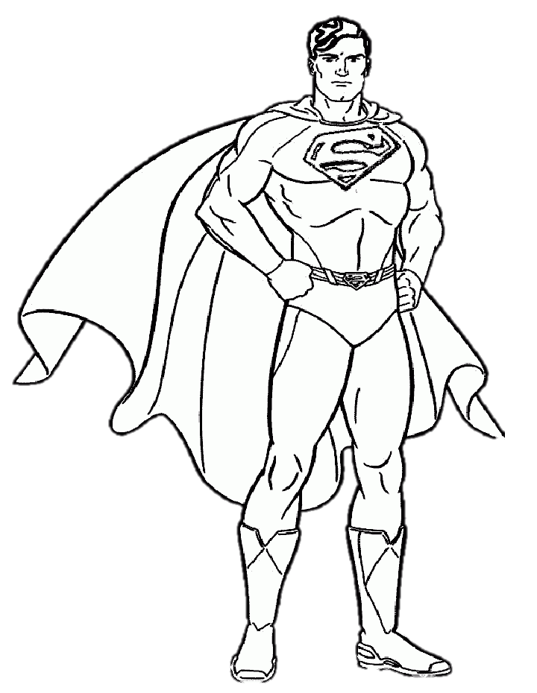
Superheroes exhibit enormous amounts of determination and bravery while attempting to reach their goals—and you can too! Choose from the superheroes shown below and color in your favorite one!
Goal Setting Like a Superhero

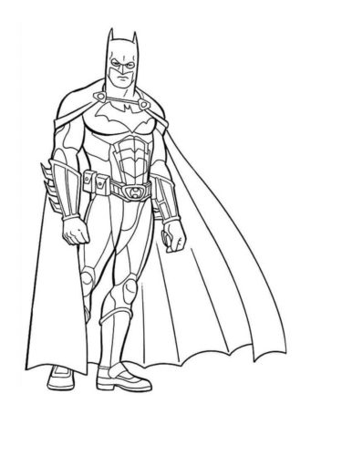
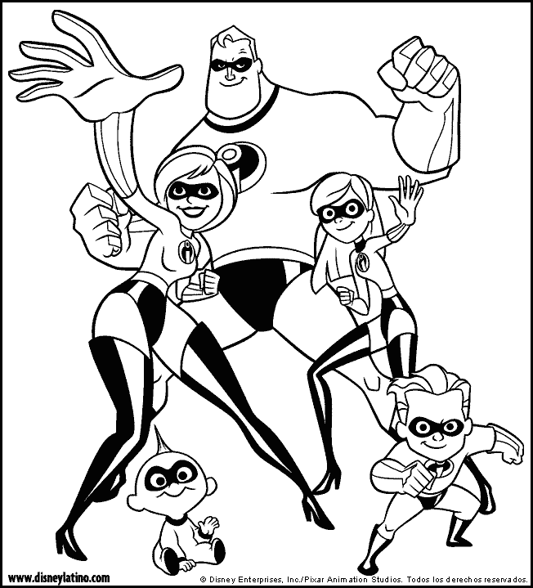

I am a superhero and will reach my goal!

Goal Setting Like a Superhero

My goal for _____________ is
___________________________
___________________________
___________________________
___________________________
___________________________
________________________________________________________.

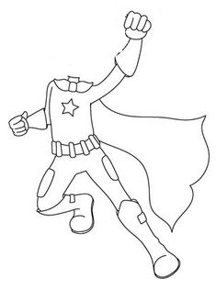
These are some things I will do to reach my goal
1._______________________________________________
2._______________________________________________
3._______________________________________________
4._______________________________________________

LESSON #3: UNDERSTANDING FEELINGS
Book Option #1: “How Are you Peeling? Food with Moods” by Saxton Freymann and Jooset Elffers

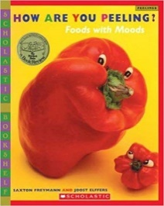
Who has looked at a fruit or vegetable and seen a funny face? The author demonstrates how fruits or vegetables have "natural personalities.” This book teaches children about emotions and recognizing them through expressions.

Prompts for Writing and Reflection:
- What happened in this story?
- What is the fruit feeling? How can you tell this fruit is feeling an emotion?
- How can you tell what you’re feeling?

Book Option #2: “The Way I Feel” by Janan Cain
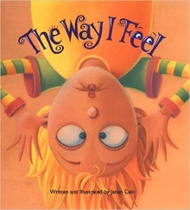
Kids are able to name their feelings in the Way I Feel and know that feelings are neither good nor bad, they just are.

Prompts for Writing and Reflection:
- What happened in this story? Who are the characters?
- What are the different feelings expressed by the children?
- What different feelings do you have as you go through your day?

Application Activity #1 or #2: Feel That Tune

Directions:
- Have the students help you create a list of various emotions/feelings.
- Using the list of songs provided below, separate both the songs and the emotions so that each is on its own individual sheet of paper. Place all songs and all emotions into two separate bins.
- Have the students take turns picking a piece of paper out of each bin so they end with one song and emotion (make sure they do not show their classmates what emotion they got).
- Have the students take turns singing the songs in the emotion they chose. (Examples: Hakuna Matata in a frustrated voice; YMCA in a sad voice, etc.) While singing, the other students must use the worksheet provided to draw or write down words describing their guess of the emotion being expressed in their classmates singing, along with the emotion the song typically makes them feel.
- Ask a volunteer to provide an example of when he or she felt that expression.

List of Songs that Can be Used:
- Hakuna Matata- The Lion King
- Bear Necessities- The Jungle Book
- YMCA
- Happy- Pharrell Williams
- Firework- Kay Perry
- Under the Sea- The Little Mermaid
- You’ve Got a Friend in Me- Toy Story
- Don’t Stop Believing- Journey
- Somewhere Over the Rainbow
- You Are My Sunshine
- ABC- Jackson Five
- Take Me Out to The Ballgame
- When You Wish Upon A Star-Disney
- I Like to Move It- Madagascar
- Do You Want to Build A Snowman- Frozen

Materials Needed:
- Feel That Tune worksheet provided, Bins (or something equivalent) for the children to pick the songs and emotions out of

**Note: I added both books because I feel this activity could work with either book

Draw a picture or write down some words in the boxes below describing (1) your guess of the emotion being expressed in your classmates singing, and (2) the emotion the song usually makes you feel
Feel That Tune

LESSON #4: UNDERSTANDING OTHERS (EMPATHY)

Book Option #3: “Those Shoes” by Maribeth Boelts

Synopsis:
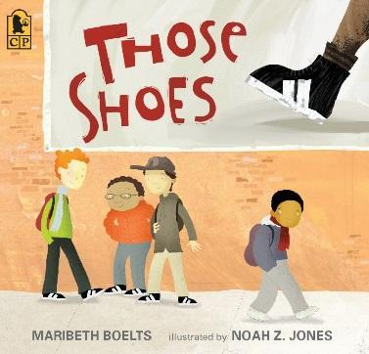
Jeremy would like to own some new and popular sneakers, but his family cannot afford them. Eventually, he finds sneakers at a thrift store and is thrilled to fit in. However, when he sees another student who needs them more than he does he is empathetic and passes them on.

Prompts for Writing and Reflection:
- What happened in this story?
- How do you think Jeremy felt giving the sneakers to the other child?
- Has anyone ever done something kind for you like Jeremy did?

Application Activity #3: Walk In My Shoes

Directions:
- Bring in some old (but clean!) shoes. Within each shoe there should be folded papers containing different scenarios on them. Each scenario will tell the story of someone who owns those pair of shoes and will ask the kids to “walk a mile in their shoes.”
- Have the kids sit in a circle around the classroom and pass the shoe around until the teacher yells stop.
- Each kid that has a shoe when asked to stop must choose a paper inside the shoe and answer the questions on how they would react/feel about the scenario.
- Have a class discussion about the scenario/answers to the questions and explain to the children why it is important to empathize with others

Example Scenarios:
- Billy asked Jacob to sit with him at lunch, but Jacob did not want to and sat somewhere else. How to you think Billy is feeling? What is something you could do to make him feel better?
- You notice Tim is saying mean things to Jimmy about his shirt and is telling him that he does not like it. How do you think Jimmy is feeling? How could you make him feel better? How could you politely ask Tim to be nicer?
- You see Leslie upset during class because her goldfish died last night. What could you say to Leslie to make her feel better?
- Patrick is sad because his best friend did not go to his birthday party. How do you think Patrick is feeling? Could you say or do anything to cheer him up?
- Haley asked Lewis is if she could join him in a game during recess and he tells her no. How do you think Haley is feeling? Could you do anything to make her feel better?
Materials Needed: Shoes; Papers containing scenarios
LESSON #5: PERSISTENCE

Book Option #1: “Little Kunoichi – The Ninja Girl” by Sanae Ishida

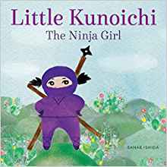
Little Kunoichi shows that being a good ninja takes a lot of determination and persistence. Ninja skills do not come easy, and Little Kunoichi never gives up!

Prompts for Writing and Reflection:
- What happened in this story? Who are the characters?
- How did Little Kunoichi reach her goals? What did she do to persist?
- When have you persisted to reach your goal?

Application Activity #1: Persistence Olympics
Within the Persistence Olympics there will be three different fun character-building activities for the children to choose from that teach perseverance. Remember to remind the children on the importance of persistence in order to reach their goals throughout the activities. At the end of the ‘Olympics,’ reward everyone with a small prize for not giving up during the activities. Those who reach their goals can pick out another small prize. If the students have time and want to do more than one activity they can do so.
Game 1 Directions: Ring Toss
- Using a ring toss set, set up a ring toss for the children. If a ring toss set is unavailable this can be done by cutting out the center of plastic paper plates and toss them at cups or mason jars
- Have the kids come up with their own goals such as: “I will make three in a row.”
- Allow the kids to continue until reaching their goal—make sure to cheer them on along the way!
Game 2 Directions: Bean Bag Toss
- Set up a bucket for the kids to throw bean bags and balls into.
- Have them set up a challenging yet attainable goal for themselves such as “I will get five in a row”
- Allow the kids to continue until reaching their goal—make sure to cheer them on along the way!
Game 3 Directions: Ping Pong Bounce
- On a table, desk, or floor set up a small container, such as a bucket or bowl, and hand the kids a ping pong ball.
- Demonstrate to the kids how you can bounce the ball and land it into the container.
- Have them set up a challenging yet attainable goal for themselves, such as getting three or so in a row.
- Allow the kids to continue until reaching their goal—make sure to cheer them on along the way!
At the end of the activities, allow all children to pick out a prize. Have a class discussion and answer the following:
  - What is persistence?
  - Why is it important to be persistent?
  - Was it hard to reach your goals during these activities? What helped inspire you to stay persistent during them?
  - How do hard work and perseverance help you achieve your goals?

Materials Needed: Ring Toss Set (or equivalent such as cutting out the center of plastic paper plates and tossing them at cups or mason jars), bean bags or balls and some buckets, ping pong ball with a small container (such as a bucket or bowl), and small prizes they can choose from (pencils, erasers, candy, etc.)

